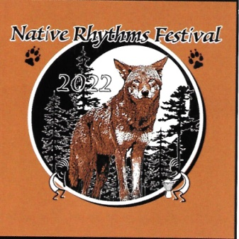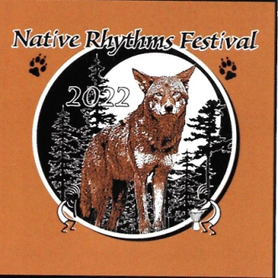
2022 Artist’s Competition
Competition Categories and Eligibility
- No member of the Native Rhythms Festival organizing committee may enter. Otherwise, this competition is open to all artists & craftspeople. Hereinafter, entrants will be referred to as artists, regardless of the medium of his/her art or craft.
- First place winner at the 2021 Native Rhythms Festival artists’ competition may not enter the 2022 competition.
- The artist must present his/her entry in person at the time and place of competition registration as specified below.
- Each artist may submit only one (1) entry. The entry may consist of multiple pieces as long as they are part of a homogeneous set and the set will be judged as a single item.
- All items must be hand-made by the artist entering it. Computer-generated art (such as created by computer controlled laser cutters) are not acceptable. All entries must be the original work of the artist; no copies or prints are permitted.
- There will be one category for this year’s competition. That category encompasses works representing either a theme from the Native American culture or representing a nature/environment theme. All entries must present a theme that falls within either (or both) aspect(s) of this category. Entries will be judged without regard to the medium of the entry.
- Any signatures or other markings that identify the artist must be covered.
- All entries must have “NRF 22” or “NRF 2022” somewhere on the entry.
- The entry fee is $20.00 (checks made payable to “NHGI”) due at the time of registration. Entry fees are not refundable.
- All art competition entrants will receive a necklace with the event’s Kokopelli image imprinted on it. Photos of necklace (with last year’s date) will be available on our event website at http://www.nativerhythmsfestival.com/Competitions.htm.
Competition Rules and Procedures
- The Native Rhythms Festival organizing committee will select not fewer than three judges who are qualified to evaluate the art/craft entries. Judges may not be related to any of the entrants. Judges will be identified and acknowledged at the event.
- The decisions of the judges are final and not subject to appeal. Competitor’s scores will not be disclosed to competitors or the public.
- All entries, with completed entry forms and the application fees, must be presented to the competition registration table between 9 AM to 10 AM on Sunday, November 13, 2022. An identification number will be assigned to each entry at registration. Judging will be “blind” in that the judges will be aware of only the identification numbers and not the identity of the submitting artist.
- Artists may sell their entry item at any time, but may not remove it from the competition area until released by the organizing committee as specified below.
- The names of the award winners will be announced as specified on the event schedule. Entrants may pick up their entry beginning one hour after the winners are announced. This notification will be announced from the main stage. This will allow festival guests to see the winning entries all in one place.
- Trophies and cash awards will be awarded for first, second, and third place finishers as follow:. First Place award: Trophy and $100. Second Place: Trophy and $75. Third Place: Trophy and $50.
- Possession or use of alcoholic beverages is prohibited by event rules. Anyone violating this rule will be disqualified from the competition and asked to leave the event grounds immediately, not to return.

Authorization to Take and Use Photographs/Video
Waiver and Release of Claims

Upon signing the "Competition Registration Form", confirms that I have read the above entitled document herein and, I hereby grant NATIVE RHYTHMS FESTIVAL, its directors, officers, agents, and designees (collectively “NRF”) non-revocable permission to capture my image and likeness in photographs, videotapes, motion pictures, recordings, or any other media (collectively “Images”). I acknowledge that NRF will own such Images and further grant NRF permission to copyright, display, publish, distribute, use, modify, print and reprint such Images in any manner whatsoever related to NRF business, including without limitation, publications, advertisements, brochures, web site images, or other electronic displays and transmissions thereof. I further waive any right to inspect or approve the use of the Image by NRF prior to its use. I forever release and hold NRF harmless from any and all liability arising out of the use of the Images in any manner or media whatsoever, and waive any and all claims and causes of action relating to use of the Images, including without limitation, claims for invasion of privacy rights or publicity.

